Customer Discovery Tool

Introduction

* **Customer Discovery is the process of developing assumptions for the questions listed below—and turning those assumptions into hypotheses which founders will then go out and test.** 
  + Who are your customers?
  + What problem(s) do your customers have that you will solve?
  + How will you solve their problem(s)?
  + How will your customers adopt your solution
* **Investors look for it.** Investors in Northeast Ohio consider proof of market validation as one of the most important factors when deciding whether or not to invest in an early-stage company. Without conducting Customer Discovery, it’s difficult to prove market validation.
* **Your competition is doing it.** There’s only so much investment dollars in the region, a thorough Customer Discovery process can set a company apart from others being considered for funding.
* **It’s the 1st step of a 4-part process.** Steve Blank, the creator of The Lean Startup movement, has developed what he calls the Customer Development process. This is a four-part process and the first stage is Customer Discovery. [Here’s a 1 min video that will provide a surface-level understanding of Customer Development and why it is a step-by-step process that must start with Customer Discovery.](https://youtu.be/TXj3F5MdHUU?t=54s)
* **Your initial assumptions are likely incorrect.** The Customer Discovery process is a vital exercise for every early-stage company because “no business plan survives first contact with a customer”. To further clarify this statement, [click here to read his post highlighting a real-world example of how one of history’s largest startup failures burned through $5.2-billion](http://steveblank.com/2010/11/01/no-business-plan-survives-first-contact-with-a-customer-%E2%80%93-the-5-2-billion-dollar-mistake/).
* **It’s not a one-time exercise.** Your product, customers, and your market will be constantly evolving and with those changes will come opportunities to revisit Customer Discovery.

How to Use This Tool

* Below you will find a series of 13 videos recorded by Steve Blank that will introduce the process of Customer Discovery. Additionally, you will also find supplemental resources below each clip that will further clarify the concepts introduced in the videos.
* The format of this tool was chosen so that from within this document you can watch a video, review the corresponding supplemental resources, and then move onto the next video. [Click here if you would prefer to watch the videos without the supplemental content.](https://startupweekend.wistia.com/projects/zt618zz0r7)

**The Phases of Customer Discovery**

**[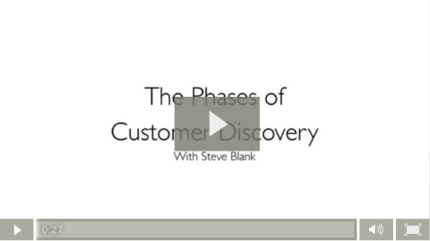](https://startupweekend.wistia.com/medias/uw3wousqww)**[Click here to watch the video](https://startupweekend.wistia.com/medias/uw3wousqww)

* One can divide the process of Customer Discovery into 3 phases
  1. Before leaving the building
  2. Outside the building
  3. Returning to the building
* The videos below are divided into these 3 phases listed above.

Before Leaving the Building

**Pre-Plan Contacts**

[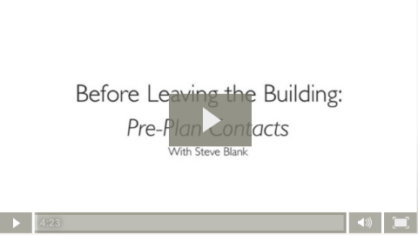](https://startupweekend.wistia.com/medias/8vbbp9qi9g)  
[Click here to watch the video](https://startupweekend.wistia.com/medias/8vbbp9qi9g)

* [Click here for a 6 min video that will help you segment your potential contacts](https://www.youtube.com/watch?v=t7UM36ZhKCU) to determine what categories of people might be most receptive to meeting with you.
* [Click here for an article that will offer 95 Ways to find your first contacts for Customer Discovery.](http://jasonevanish.com/2013/08/11/95-ways-to-find-your-first-customers-for-customer-development-or-your-first-sale/) Some of these methods might be outdated, but the list’s sheer volume of suggested methods will allow you to apply modern-day equivalents.
* [Click here for an article that provides additional methods for reaching out to potential contacts.](http://www.cindyalvarez.com/best-practices/customer-development-interviews-how-to-finding-people) It also provides a template for an email and a Twitter introduction.
* [Click here for an article and 5 min podcast that suggests how to get meetings with busy people.](http://steveblank.com/2013/08/12/how-to-get-meetings-with-people-too-busy-to-see-you/)

**Customer Interview Dry Runs**

**[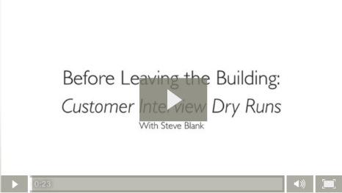](https://startupweekend.wistia.com/medias/44g3o8d37g)**[Click here to watch the video](https://startupweekend.wistia.com/medias/44g3o8d37g)

* Doing customer interview dry runs with your teammates before leaving the building has numerous benefits.
  1. If multiple team members will be going out individually to conduct interviews, these dry runs will ensure that there is some degree of conformity in what you are saying to the contacts and what you intend to learn from these conversations.
  2. Practicing will allow for an opportunity to critique and improve the script.
  3. As Steve Blank mentioned, practice breeds confidence. For many of you, this will be the first time you share your idea outside of the building. Hopefully you will be interviewing individuals who down the road may be your first customers...it is obvious why you will want these interviews to go as smoothly as possible.

**Discovery is for Founders**

**[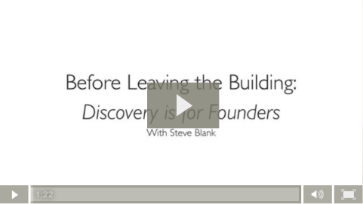](https://startupweekend.wistia.com/medias/oq6nyt2hqs)**[Click here to watch the video](https://startupweekend.wistia.com/medias/oq6nyt2hqs)

* Why Founders?
  + It is highly encouraged that founders/decision-makers be the ones to conduct customer interviews as opposed to employees/consultants.
  + [Click here for a 6 min video that tells a real-world anecdote of what happens when a founder is in the field vs delegating Customer Discovery to employees/contractors.](https://www.youtube.com/watch?v=PTAGwfWpbjg)
* The Business Model Canvas
  + In the video above, Steve Blank mentions the [Business Model Canvas](http://staging.jumpstartinc.org/education/leanstartup/business_model_canvas_poster.pdf). It is highly encouraged that all entrepreneurs go through the exercise of filling out the sections of the BMC in order to develop a complete picture of a business.
  + [Click here for a 4 min video that explains the BMC](https://www.youtube.com/watch?v=wlKP-BaC0jA) and [click here for 1 min video of Steve Blank illustrating how the tool allows you to organize your hypotheses while you are conducting Customer Discovery.](https://www.youtube.com/watch?v=PFlSiHWaaMs&list=PLw540Wq5kay8RCvYu7D5r5wZcedug-kZO&index=1)
* The Pivot
  + Also in the above video, Steve Blank introduces the concept of the pivot. A pivot is “a substantive change to one of more of the business model canvas components”. [Click here for a 2 min video that further clarifies this concept and how it relates to a startup undergoing Customer Discovery.](https://www.youtube.com/watch?v=p9AuCQTzbgo&list=PLw540Wq5kay8RCvYu7D5r5wZcedug-kZO&index=7)

**Plan Ahead What Questions To Ask, How To Ask Them, and Why You Are Asking Them**

[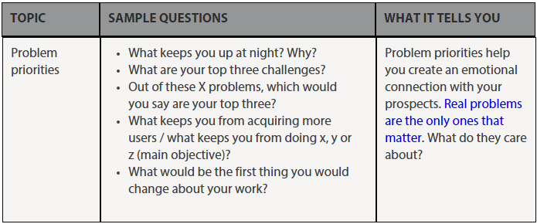](http://leanb2bbook.com/blog/b2b-customer-discovery-interview-questions-the-master-list/)

* It is vitally important, before you leave the building, to discuss with your team what questions to ask and why you are asking them. [Click here for an article that reinforces this notion.](http://www.cindyalvarez.com/lean/what-would-we-do-if-we-had-an-answer-to-that-question)
* Having a format for your interviews will ensure some degree of conformity. [Here’s an article that shares a suggested structure for a Customer Discovery interview.](http://jasonevanish.com/2012/01/18/how-to-structure-and-get-the-most-out-of-customer-development-interviews/)
* Every answer to one of your questions could tell you a lot. [Here’s an article that lists some of the things you should be learning from your conversations and walks you through an example of an interview while providing an explanation behind each question asked.](http://www.cindyalvarez.com/communication/customer-development-interviews-how-to-what-you-should-be-learning)
* [Click here for a master list of Customer Discovery questions and an explanation of what you will hope to learn from each response.](http://leanb2bbook.com/blog/b2b-customer-discovery-interview-questions-the-master-list/)
* A great last question is “what else should I have asked you?”

**Pass/Fail Experiments**

**[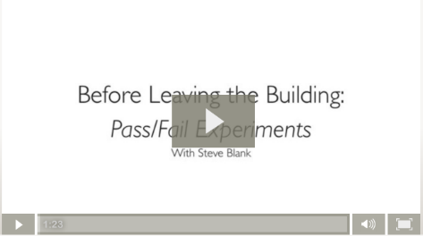](https://startupweekend.wistia.com/medias/v0t4qkdxbn)**[Click here to watch the video](https://startupweekend.wistia.com/medias/v0t4qkdxbn)

* Make bets with yourself on if your assumptions are correct.
* Clearly define what constitutes as a passing assumption vs a failing assumption.
* Plan how you will gain insight on why your assumptions were correct/incorrect
* [Click here for an article that walks through creating pass/fail experiments](http://startuplansing.org/five-tips-for-designing-customer-discovery-experiments/)

Outside The Building

**Being Aggressive**

**[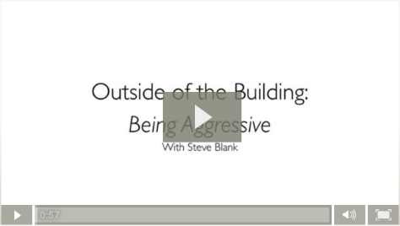](https://startupweekend.wistia.com/medias/xxj6xin5fm)**[Click here to watch the video](https://startupweekend.wistia.com/medias/xxj6xin5fm)

* “In the US, be so aggressive that you get thrown out of buildings” – Steve Blank
* This clearly shouldn’t be interpreted as encouraging you to be rude, but it’s important for entrepreneurs to get to the bottom of their assumptions before they pour too many of their resources (time, money, etc.) into untested ventures.

**Conducting a Customer Interview**

**[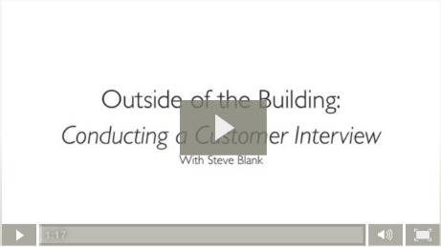](https://startupweekend.wistia.com/medias/zzgwczbb4w)**[Click here to watch the video](https://startupweekend.wistia.com/medias/zzgwczbb4w)

* Mock Interviews
  + [Click here for a 10 min video of a mock customer interview](https://www.youtube.com/watch?v=V3syNbgSkwE) with narration by Steve Blank
  + [Click here for an article that offers a written example of a mock customer interview](http://www.cindyalvarez.com/communication/customer-development-interviews-how-to-what-you-should-be-learning)
* Customer Interview Tips
  + [Read customer interview tips article #1](http://www.dancingmango.com/blog/2012/12/14/twelv-tips-for-customer-development-interviews/) and [customer interview tips article #2](http://giffconstable.com/2012/12/12-tips-for-early-customer-development-interviews-revision-3/)
  + [Check out an article on what you should NOT be doing during customer interviews](http://giffconstable.com/2013/06/11-customer-development-anti-patterns/)
  + Attempt to conduct your interviews in a casual manner so the interviewee doesn’t relate it with a traditional sales presentation
  + Always ask your interviewees for referrals to 2-3 others who are roughly in your target market so you can interview them next. These leads will have a much higher response rate than ones you reach out to with a cold call.
* When To Stop Customer Interviewing
  + There’s no magic number of interviews you must do in order to validate your assumptions. Very rarely will you ever do too many interviews, but you can [click here for an article that discusses how many interviews is too many](http://mfishbein.com/how-many-customer-development-interviews/)
  + Additionally, [click here for an article that also attempts to explain when it’s time to stop the interviews and start executing.](http://blog.asmartbear.com/stop-customer-interviews.html)

**Letting the Customer Interview Flow**

[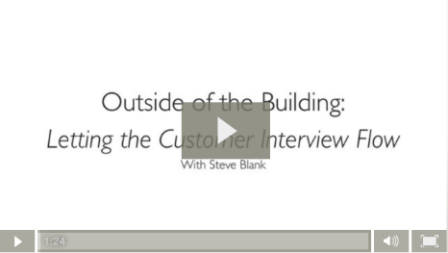](https://startupweekend.wistia.com/medias/pyrarw4soy)  
Click here to watch the video

* When you are in front of your interviewee and you are reading off a list of questions on a piece of paper the interview will feel more structured. As a result, the conversation might not be feel casual enough to allow the person to give you valuable off-the-cuff insight.
* Your goal is to have the conversation be as casual as possible to allow the customer to give you unscripted insight, but you still want to be able to consistently hit all of your talking points.

**Sizing the Opportunity & Market Type**

**[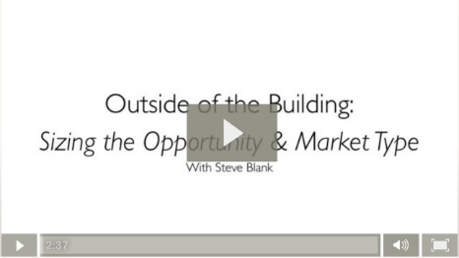](https://startupweekend.wistia.com/medias/3az5bpusmi)**[Click here to watch the video](https://startupweekend.wistia.com/medias/3az5bpusmi)

* Product-Market Fit
  + Customer Discovery is a search for what is called a Product-Market Fit. [Click here for an article that helps define the concept](http://seedcamp.com/resources/the-product-market-fit-cycle/) and [click here for another article in which well-known entrepreneur Marc Andreessen argues that finding Product-Market Fit is “the only thing that matters”.](http://web.stanford.edu/class/ee204/ProductMarketFit.html)
* Market Analysis – Size, Competition, Growth Potential
  + [In this 1 min video Steve Blank introduces the importance of market analysis – market size, competition, growth potential](https://www.youtube.com/watch?v=CHh49_ZtY8I&index=11&list=PLw540Wq5kay8RCvYu7D5r5wZcedug-kZO)
  + Before you leave the building, it’s prudent to determine the size of your potential customer market. You can have the greatest solution in the world, but if there is only a small amount of potential customers who have the problem that your solution solves…you may not be able to make a return on your investment.
  + [In this 4 min video Steve Blank illustrates market sizing with Total Available Market (TAM), Served Available Market (SAM), and Target Market](https://www.youtube.com/watch?v=_-N5u7i_Vgk&list=PLw540Wq5kay8RCvYu7D5r5wZcedug-kZO&index=12)
  + Watch [this 3 min video Steve Blank walks through a real-world example of market sizing](https://www.youtube.com/watch?v=xaoHNAGn1dg&index=13&list=PLw540Wq5kay8RCvYu7D5r5wZcedug-kZO)
  + If you are estimating the size of a B2B market, please refer to [B2B market sizing article #1](http://blog.openviewpartners.com/b2b-market-sizing/) and [B2B market sizing article #2](http://blog.openviewpartners.com/b2b-market-sizing-approaches-how-to-assess-a-market-opportunity/)
* Market Type
  + Steve Blank also stresses the importance of understanding your “market type”. For example, are you entering an existing market, a re-segmented market, or a new market?
  + [Click here for an article he wrote that clarifies the significance of market type by using two real-world examples.](http://steveblank.com/2009/09/10/customer-development-manifesto-part-4/)

**Finding Patterns**

**[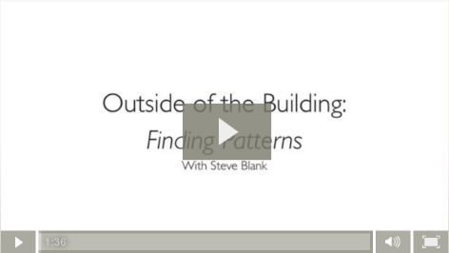](https://startupweekend.wistia.com/medias/tgak8ondjr)**[Click here to watch the video](https://startupweekend.wistia.com/medias/tgak8ondjr)

* The overriding purpose of the Customer Discovery process is to identify patterns in the data you collect from your interviews.
* [Click here for an article that suggests how to organize customer interview feedback in order to draw insight.](http://customerdevlabs.com/2013/09/10/customer-development-notes-finished-post-its/) The article also introduces a useful free online sticky notes tool called [lino](http://customerdevlabs.com/2013/09/10/customer-development-notes-finished-post-its/)
* Steve Blank asserts that “until you start hearing the same thing over and over again…your Customer Discovery is not done”. Until you are done with Customer Discovery, you are not ready to move onto the next step in the Customer Development process, Customer Validation.

**Looking for Insights**

**[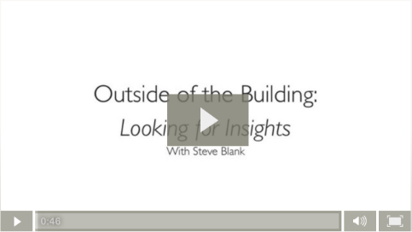](https://startupweekend.wistia.com/medias/pygn8b90g8)**[Click here to watch the video](https://startupweekend.wistia.com/medias/pygn8b90g8)

* Train yourself to look for customer/market/industry insights
* You might discover the customers care about a surprising aspect of your solution that you wouldn’t have previously considered as important
  + For example, your team might spend most its time developing features X and Y of your product, but the customers are surprisingly mostly excited about feature Z
* [In this 6 min video Steve Blank illustrates a real-world evolution of a Business Model Canvas throughout the Customer Discovery process and how gained insight changes business plans](https://www.youtube.com/watch?v=iaGHZ3tkaiQ&index=16&list=PLw540Wq5kay8RCvYu7D5r5wZcedug-kZO)
* Watch a [3 min video in which Steve Blank clarifies the extent of insight one should be gathering from Customer Discovery conversations](https://www.youtube.com/watch?v=V3syNbgSkwE&feature=youtu.be&t=7m14s)

Returning to the Building

**Finding Early Evangelists**

**[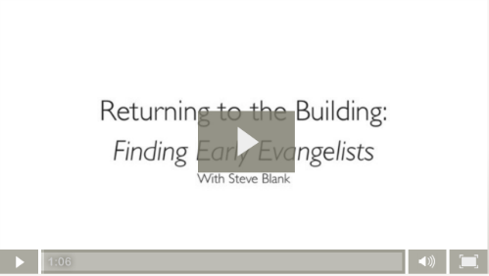](https://startupweekend.wistia.com/medias/2az6xaxhgk)**

[Click here to watch the video](https://startupweekend.wistia.com/medias/2az6xaxhgk)

* Early evangelists are people who
  + See your product even better than you do
  + Envision the progression of your product development 18 months into the future
  + Have been looking for a while to solve the issue your product solves
  + Will put up with buggy software, MVP’s/prototypes
  + Will introduce your product to others
* [Click here for a 4 min video that identifies early adopters and explains why they’re so important](https://www.youtube.com/watch?v=WxD2JME3GSU)
* [Review an article covering how to identify early adopters and strategies to reach out to them](https://startupjuncture.com/2015/03/31/lean-startup-how-to-find-early-adopters/)
* Read [this article in which Harvard Business School professor Michael Skok introduces the concept of Minimal Viable Segment.](http://mjskok.com/resource/gtm-segmentation-mvs-targeting) Early adopters will often be found within your MVS.
* Entrepreneur Eric Ries [in this 4 min video tells of his real-world experiences with early adopters and he offers some suggestions on how to find them](https://www.youtube.com/watch?v=Jf2IVX5dUkg)

**Communicating Your Discoveries**

[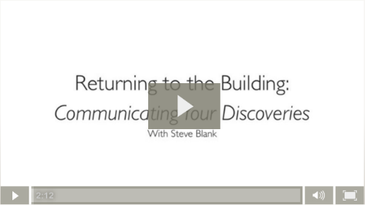](https://startupweekend.wistia.com/medias/3pwv31cp98)  
[Click here to watch the video](https://startupweekend.wistia.com/medias/3pwv31cp98)

* You need to effectively communicate to your team what you learned in your customer interviews
* Do not return from an interview and immediately run into your office screaming that the company needs to pivot…this will drive your team (especially the technical members) crazy
* Sit on what you learned for 72 hours and share with co-founders or advisors before jerking around your development team

**Prepare for Customer Validation Process**

**[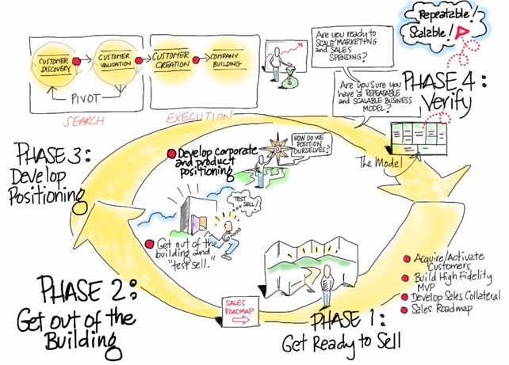](https://www.youtube.com/watch?v=ewEtBz9SST4&list=PLw540Wq5kay8RCvYu7D5r5wZcedug-kZO&index=10)**[Click here to watch the video](https://www.youtube.com/watch?v=ewEtBz9SST4&list=PLw540Wq5kay8RCvYu7D5r5wZcedug-kZO&index=10)

* Once you believe that you have used the process of Customer Discovery to determine your Product-Market Fit, then you should move onto the Customer Validation phase of Steve Blank’s 4-phase Customer Development process.
* During Customer Validation you will be once again be getting out of the building to meet with customers, but this time your goal will be to sell your product or get users (depending on your business model)