Go-To-Market Strategy Worksheet

**Instructions:** You could have the best solution for a particular problem, but if the people or organizations with the problem aren’t aware of your solution…you essentially have nothing. Reaching and engaging customers is vital to the success of an early-stage company. Please answer the below questions to the best of your ability.

**Who is your specific target customer?**Please be very descriptive when explaining their pain points, demographics, and anything else that makes them unique. If you are a B2C company, please include a buyer persona. If you have multiple customers, please just highlight the one with the greatest need for your solution.

**If you were to describe your brand, what are 3-5 of words or phrases you’d want associated with it?**If you have already entered the market, do you think your customers would provide the same 3-5 phrases if they were asked to describe your brand?

**What are 2-5 fundamental promises you can make to your customer that you can confidently deliver on once you enter the market?**

**Where does your target customer exist? In other words, where can you find your customers?**

**What are 2-5 marketing channels that you plan to use to reach your target customer?**

**Considering the sales cycle graphic depicted below, please list the following for each of the 6 stages of your business’s sales cycle:**

1. **The duration in hours, days, weeks, or months for a lead to start at the beginning of a stage and progress to the beginning of the following stage. In other words, how long does the customer spend in each stage.** If a particular stage doesn’t apply to your sales cycle, please just list the time as zero.
2. **The tactics you will employ at each stage of the cycle that will result in the lead moving forward in the process.** Please be aware that the same tactic might work for more than one stage.

**\*\*\***Please just make your best assumptions. No early-stage company is going to be 100% accurate. ***

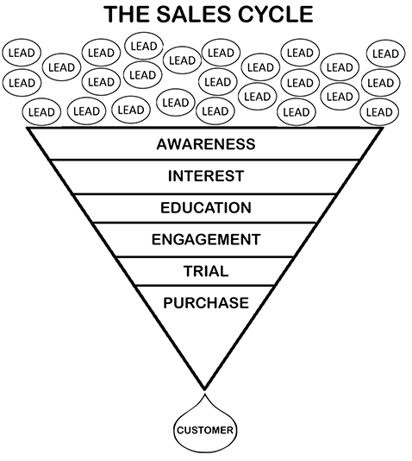

**Awareness Stage**

Time:

Tactics:

**Interest Stage**

Time:

Tactics:

**Education Stage**

Time:

Tactics:

**Engagement Stage**

Time:

Tactics:

**Trial Stage**

Time:

Tactics:

**Purchase Stage**

Time:

Tactics: