Pitching Investors: The Ultimate Pitch Bible

Introduction

The goal of this document is to provide a real-world best practices approach to creating an investor pitch. Most of the example slides displayed throughout this document will be the actual pitch deck used by a company called Beegit. You can [watch the full 13-minute presentation on YouTube here.](https://www.youtube.com/watch?v=FAc7LCy5NPg)

Before we delve into the pitch structure materials, here are some helpful tips to keep in mind as you are going through the process of creating and delivering your pitch.

Helpful Tips

**Preparation:**

* **Investors are busy people**. If you can’t grab their attention in the first 30 seconds then you risk losing them for the entire pitch. The best way to avoid this is to QUICKLY get to the problem you are solving.
* **Do homework on your audience/investors**. Why? Because the more you are able to relate your company to what they do or care about, the more likely you are to spark their interest. Find out what kind of companies they fund. It never hurts to attempt to contact a company that was successfully funded by the investors you are going to pitch to and see if the company will give you some guidance on what to expect and best practices.
* **Understand one size does not fit all**. Based on your market, business model and technology, you may choose to introduce the product before you introduce the market, or the other way around, for example. You will need to gauge your approach based on your audience and the novelty of the technology. The underlying rule is that the presentation should flow smoothly, while taking the audience through your story.
* **Ensure every slide has a purpose.** For every slide, ask yourself “what is the takeaway for the audience from this slide?” and “does the content here communicate my message”? If you can’t clearly explain that…then modify or eliminate the slide. Every slide counts in telling the story and an extra slide can confuse your audience. Any confusion can undermine your credibility.
* **Understand that less is more.** No investor wants to or will read a wall of text on a slide. Use images and key words that the audience can connect to while listening along.
* **Site your facts.** Reference every statistic and claim that you are using to validate your business. You will lose the investor if they don’t believe your claim is credible.
* **Sell the investor on your business.** The pitch deck is the most important SALES pitch you need to make. Don’t just make it informational. You need to convince the investor that your solution solves a big problem if you want them to “buy” into your business. If it lacks the reasoning on why an investor should invest in your company (it’s an investment not a purchase), then don’t expect it to happen.
* **Stress the ROI.** For an investor to invest in your business, you have to make it very clear how they will generate returns on their investment, not how great you think your product really is. You have a great opportunity for the investor if he/she believes that they will make significant returns on their investment, otherwise why would you expect someone to invest? A savvy investor will always be focused on how much funding you will need to raise to be successful, how many different funding rounds you should expect to have over the life of your company and how much dilution their investment will be subject to.
* **Convey adaptability.** Investors are looking for entrepreneurs who are willing to pivot as time goes on. Convey that you are ready to make necessary changes down the road if needed. Very rarely are founder’s initial pathways to success 100% accurate. For example, industry changes or regulations often cannot be predicted and are events that a founder will have no control over…or you might find a better use for your technology in another industry.
* **Don’t give them a reason to not invest.** Investors are looking for a reason, any reason, not to invest. If there is anything in your message or slides that gives them pause, then they may pass. At the end of the day, it’s smarter and safer to pass on an investment. Don’t give them a reason. Investors are looking for low risk, high reward.
* **Don’t dismiss it as a one-time-interaction.** After the presentation, if you are not funded, take the opportunity (if available) to hear the investors’ feedback. Find out what you could have done differently and what they would want to see you improve on if you were going to pitch to them again in the future. Don’t ever look at an investor pitch as a one-time-interaction with no second chance. In some cases, companies have pitched to the same investor several times before getting funded.
* **Prepare in advance for funding.** [This Harvard Business School video titled Foundations of Financing and Capital Raising for Startups](https://www.youtube.com/watch?v=qhRD64AlBrU&index=8&list=WL) provides a straightforward overview of topics such as: preparing your company for the financing process, the different sources of capital, and legal and regulatory considerations.
* **Learn from the experts.** For expert tips on the pitch process, [Here’s a Harvard Business School video on Getting Behind Your Pitch](https://www.youtube.com/watch?v=YkH-NvWHpRo) and [another video presented by a VC titled “The Best Pitch Decks: How to Create a Winning Pitch Deck”](https://www.youtube.com/watch?v=fXcKWADoRWQ)
* **Review examples.** Here are resources that provide pitch deck examples:
  + [Pitch Deck Coach](http://pitchdeckcoach.com/pitch-deck) – sample pitch deck with comments
  + [LinkedIn's Pitch](http://reidhoffman.org/linkedin-pitch-to-greylock/) – LinkedIn’s old pitch deck with comments
  + [Pitch Envy](http://www.pitchenvy.com/) – website that shares many pitch examples

**Pitching:**

* **Tell a story that flows.** Putting facts on slides is important, but it will not get your message across as well as having slides that consecutively build on the next. A good sanity check is to go through your deck and assign one key sentence for what each slide is trying to say and see if the concepts connect.
* **Pitch by analogy.** Don’t be afraid to compare yourself to other, similar companies.
* **Let the best presenter present.** There is no shame in letting someone else from your team present if presentation skills are not your personal strength. There is no hard rule that requires the CEO to do the pitch. It’s certainly more commonplace for the CEO to present, but not absolutely required. The CEO needs to convey leadership; so one way of demonstrating that you can leverage the capabilities of your team is to empower them to present.
* **Don’t get defensive.** Be prepared to take criticism without getting defensive, even if you think the person you are pitching to is dead wrong. They may have experience you don’t or may simply be trying to find holes in your story to see how you handle the situation. Their mentality may be that they are also trying to figure out if they will be able to work with you through various issues that may arise. They don’t want to be stuck in a deal in which adversity is just going to bring up conflict. Would you hire someone like that for your company?
* **Avoid investment ambiguity.** In order to ensure the investor is even interested in your company and that you meet the criteria necessary to receive their funding, do advance research or ask them upfront to clarify their preferences for investment. One of the biggest mistakes entrepreneurs make is not understanding right up front what an investor is looking for in an investment.

**Sharing Content:**

* **Format your pitch for sharing.** Create your deck so it can easily be printed or understood in a PDF, which has no animation graphics. If your message requires build slides and other animations, create a separate deck that will be able to stand on its own when printed. Also expect it will be shared and you don’t want people getting confused on static build slides.
* **Don’t email the PowerPoint.** Send your pitch in a PDF or you run the risk of having the design and formatting ruined upon transferring computers.

Sample Pitch Deck with Supplemental Advice And Resources

This is the suggested flow (order) of slides for your presentation. As mentioned previously, feel free to modify the order of your specific pitch deck if an alternative structure makes it flow better.

Investor Pitch Deck Structure

[1. Company Purpose / Introduction 5](#_Toc431366277)

[2. Problem 6](#_Toc431366278)

[3. Solution / Product / Service 9](#_Toc431366279)

[4. Traction 11](#_Toc431366280)

[5. Market Size/Opportunity 12](#_Toc431366281)

[6. Competition 14](#_Toc431366283)

[7. Go to Market Strategy 16](#_Toc431366284)

[8. Financials 18](#_Toc431366285)

[9. Team 20](#_Toc431366286)

[10. Summary Slide 21](#_Toc431366287)

[11. Appendix 22](#_Toc431366288)

## **Company Purpose / Introduction**

* Define the company in a single declarative sentence. [See examples of introduction slides at Pitch Envy](http://www.pitchenvy.com/).
* OR give your 30 second elevator pitch. [Here’s a Harvard Business School video on Telling Your Story.](https://www.youtube.com/watch?v=cUs4lX-fsFE&list=WL&index=5)
  + Make sure that you clearly understand and can articulate your value proposition. [Here’s a Harvard Business School video on Value Proposition.](https://www.youtube.com/watch?v=6pKW-ehL7dU)
* OR use a “power statement” to explain how your product is analogous to another situation that proved to make a real difference. The statement should answer the question of “*Why should I listen to you?*”

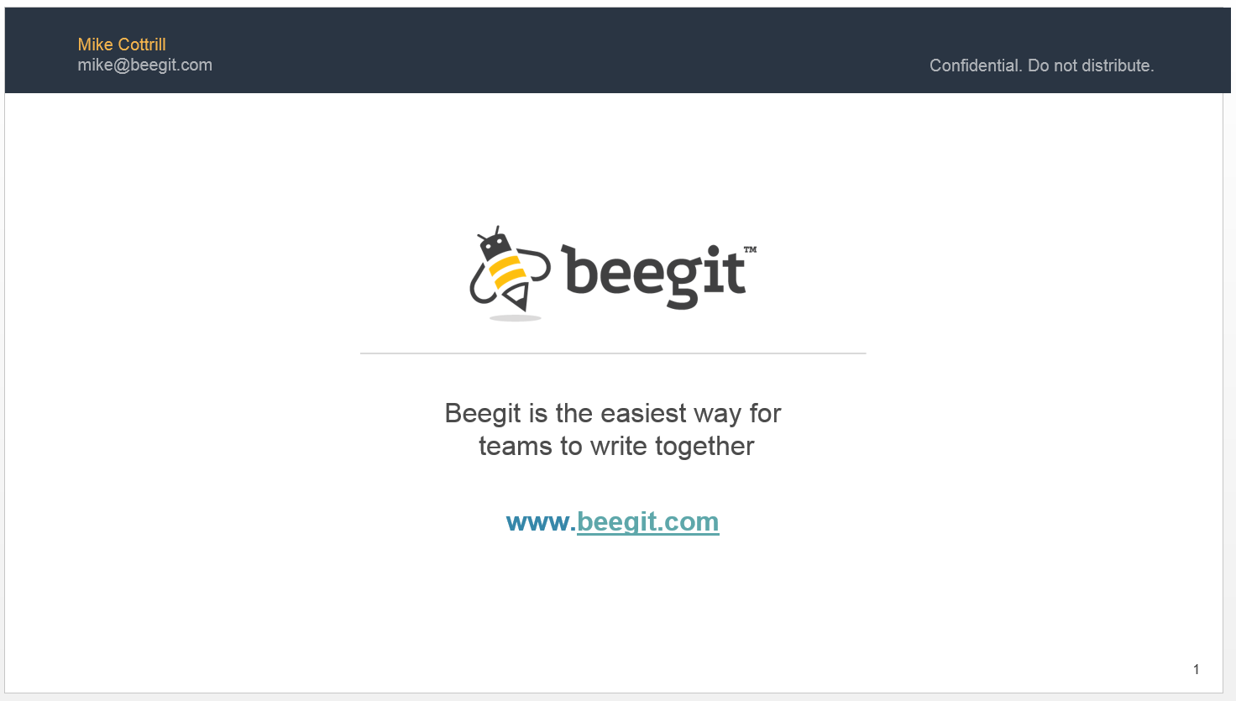

***What to Do:***

* This is your chance to begin to orient your audience with who you are, what you do, and how you do it. Don’t get detailed, just scratch the surface.
* The opening slide should be clean and simple.
* Some say your opening slide should just have your company’s name, logo, and a single declarative statement with a more-or-less blank background. Others would say that along with your name, logo, and your declarative statement, you shouldn’t be afraid to include an image that helps describe what your company does. For example, if you are in the hotel booking industry but your company’s name/logo doesn’t allude to this, you may want to include an image of a clean hotel room.
* Prepare a one-page tear-sheet to handout if helpful to support the presentation.
* Include your contact info on the opening slide.

***What Not to Do:***

* Do not sell your product, but instead sell your company. Investors are not buying your product, they are buying into your company/business.
* Do not cram too much information onto the slide. Simplicity and clarity are key.
* Avoid comparing yourself to market dominators like Amazon and Facebook. Those companies are extremely unique through a combination of tech, smarts, funding and luck. Select companies that are closer to your business model, market and relevance.

## 

## **Problem**

Imagine that you are trying to convince someone that there is a real issue with something of great concern. You would build your argument by first making sure he/she understood the subject matter you are talking about and that they can relate to it. For example, let’s say you hate drinking your coffee when it gets cold. If you wanted to share your frustration with a colleague who didn’t drink coffee, you would want to begin by saying to them “*did you know that 90% of the country only likes to drink their coffee or tea when it is hot (according to a really reputable source)?*” Next you would want to convey the pain hot beverage drinkers like yourself experience because you want your coffee hot. For example, you might disclose that “*X amount of money and X amount time is wasted nationwide on constantly buying new hot coffee or making tons of trips to the microwave to heat up coffee that has gone cold*”. In the process you might even throw out some more facts and figures and even tell a story about Joe “*who added up his monthly trips to Starbucks because of this problem and found out that with the money he spent he could replace a car payment*”. When positioning the problem, this is exactly what you are trying to do, but with your own product/solution.

* Describe **the problem or pain point** your product or service will solve for without talking about your product. Someone has got to buy into the problem before they hear about solving it (that will come next section, Solution/Product/Service).
* Define **THE NEED** (nice to have or need to have) – in the case of Beegit, companies need to work more efficiently as a team to create digital content (i.e. time savings & cost savings).
* Define **THE PAIN** – in the case of Beegit, it is difficult to manage team-produced digital content due to communication and productivity gaps.
* Define **THE STATUS QUO** - how does the customer currently addresses the problem and the extent to which the current solutions solve the problem.

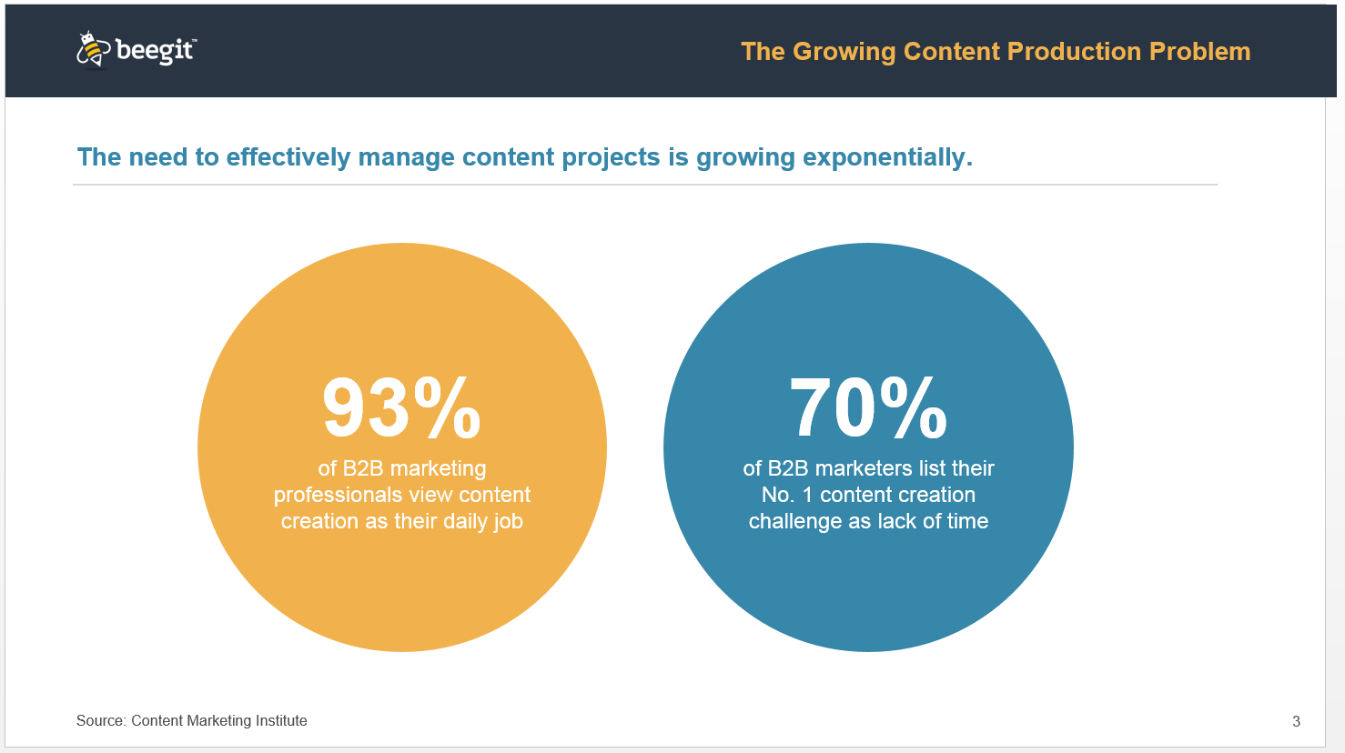

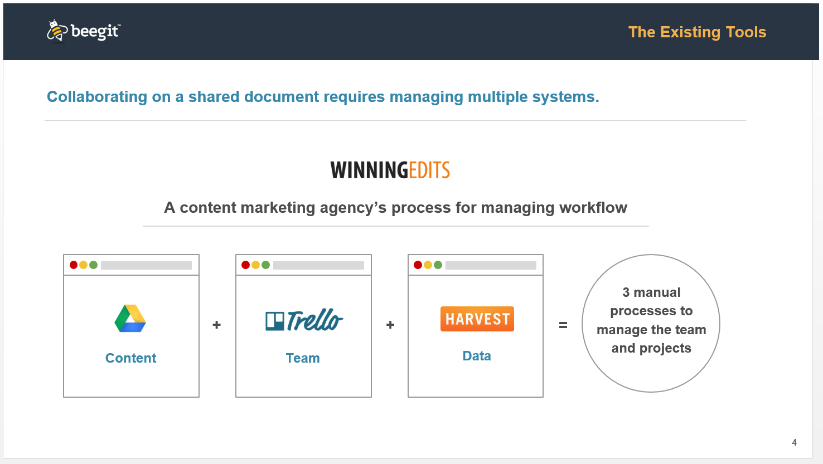

***What to Do:***

* Consider situations that will help you connect with the investors (assuming that is your audience), which may involve doing a little research into their background. Assume that they don’t have the same background as you. Their understanding of the market problem might be unclear. It is your job to not only make them understand, but also to make them excited about it.
* Display market data supportive of the size, extent, or number of people affected by the problem. You need numbers. Who? How much? How often?
* Make sure to establish how serious the problem is in the market.
  + Is the problem Unworkable? Unavoidable? Urgent? Underserved? [Click here for an article by entrepreneur/investor Michael Skok that includes sections on defining and qualifying a problem using the 4 U’s and BLAC analysis](http://www.forbes.com/sites/michaelskok/2013/06/14/4-steps-to-building-a-compelling-value-proposition/)
* Have a story to illustrate the problem. There is no better way to bring it down to a personal level for an audience that might have no knowledge of your market. Tell the audience how it affects “Bob, my next door neighbor”. If you can’t bring it down to a human level, then your audience can’t really buy into this being a real problem.
* If the problem is complex, make sure to use visuals.
* Explain if there was a change or evolution in the industry that has led to the need for your solution. A good question to be able to answer is “why now?”

***What Not to Do:***

* Do not list too many problems. It can be tempting to list all the problems your product solves, but instead you should list the most apparent problems that will directly tie with your product’s value-adding features
* Do not list a problem that your product does not solve. The investor will be expecting you to tie back every problem you list to your product’s solutions.
* Do not fail to craft your pitch as a story.

## **Solution / Product / Service**

* What is your solution?
  + **WHAT**: “We developed \_\_\_\_\_\_\_\_\_\_ to reduce, increase, etc…”
  + **WHO:** clarify**,** specifically, who will benefit from your solution. You will have an opportunity to dive deeper into the “who” and how many “who’s” are out there in the proceeding Market Size slide.
  + **HOW**: “We do this by \_\_\_\_\_\_\_\_\_\_.” Explain how you do it? What is the “Secret Sauce” behind your product of service? “We do this by \_\_\_\_\_\_\_\_\_\_\_\_” (solution and value proposition).
* What is the **VALUE** of your solution?
  + “The result is that \_\_\_\_\_\_\_\_\_\_.” Explain the savings in terms of money, time, etc. You can talk about satisfaction and efficiency but you will get the best result through quantifying the value. [Here’s a Harvard Business School video on Value Proposition](https://www.youtube.com/watch?v=6pKW-ehL7dU)
  + Note: another option is to put the “value” on a separate slide if you can’t fit it all on one slide
* Provide use cases. Once again, you should be telling a relatable story. [Here’s a Harvard Business School video on Telling Your Story.](https://www.youtube.com/watch?v=cUs4lX-fsFE&list=WL&index=5)

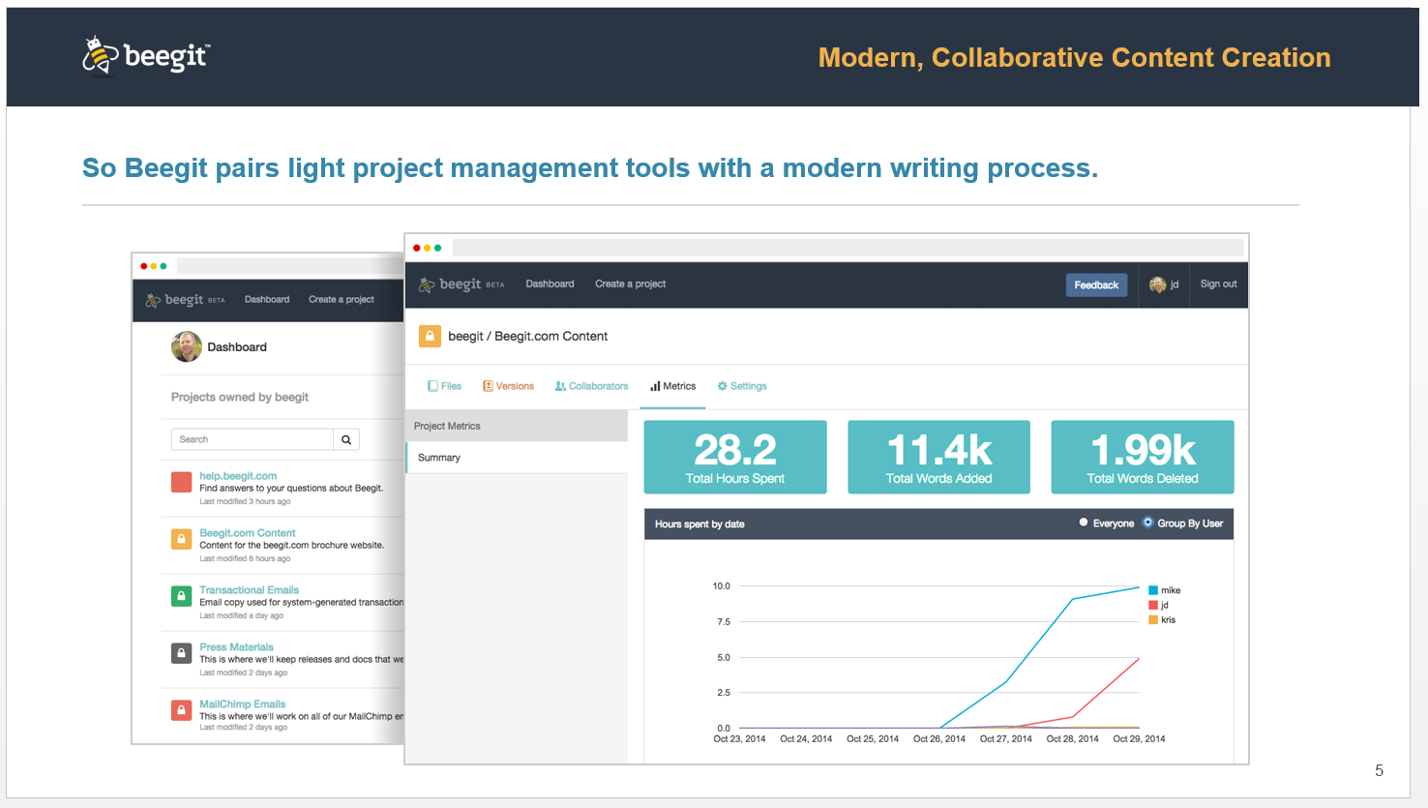

***What to Do:***

* Be clear about how your product works in delivering the value. If you can’t explain how your solution solves a problem in a single sentence, then you run the risk of confusing your audience. Try to have one sentence for every value you believe your product delivers.
* If your product’s features offer multiple solutions, ensure that each solution ties back to a problem your listed in your previous “Problem” slide. Investors will be keeping track of this as you present.
* A popular way to relate the problem to the solution is to have a “Before Solution vs After Solution” slide that highlights how it was before the solution and how it is after the solution. For example, Beegit uses the “Simplifying Workflow” slide seen below. Here’s an [example of a before vs after from a past LinkedIn pitch](http://reidhoffman.org/wp-content/uploads/2013/05/Slide05.jpg).
* Quantify the value, in a chart if appropriate.
* You can choose to follow up with an additional slide on how your early customers have benefited.
* If there is intellectual property considerations for your product, articulate the underlying claims.
* Your solution should ideally be a “must have” vs a “nice to have.”

***What Not to Do:***

* Try not to use big words or acronyms.
* Do not recite an essay on your product. The audience simply wants to know that it works as described. They will schedule a technical deep dive if interested.
* No need to get too technical. Your explanation should be an inch deep and a mile wide.
* Be wary of a demo, unless it helps to better sell your company, not your product.
* Do not spend all of your time listing features versus the benefits tied to the value proposition. Focus on effectively conveying the main value proposition important to the audience rather than “nice to have” features that create a distraction.
* It’s okay for one person to do the entire presentation, but don’t be afraid to let your CTO or technical team member explain the product. It’s good to show you can work with a team that complements each other.

## **Traction**

* Growth metrics are key for an early stage startup.
* Show growing demand for your solution due to time/money saved or attention gained

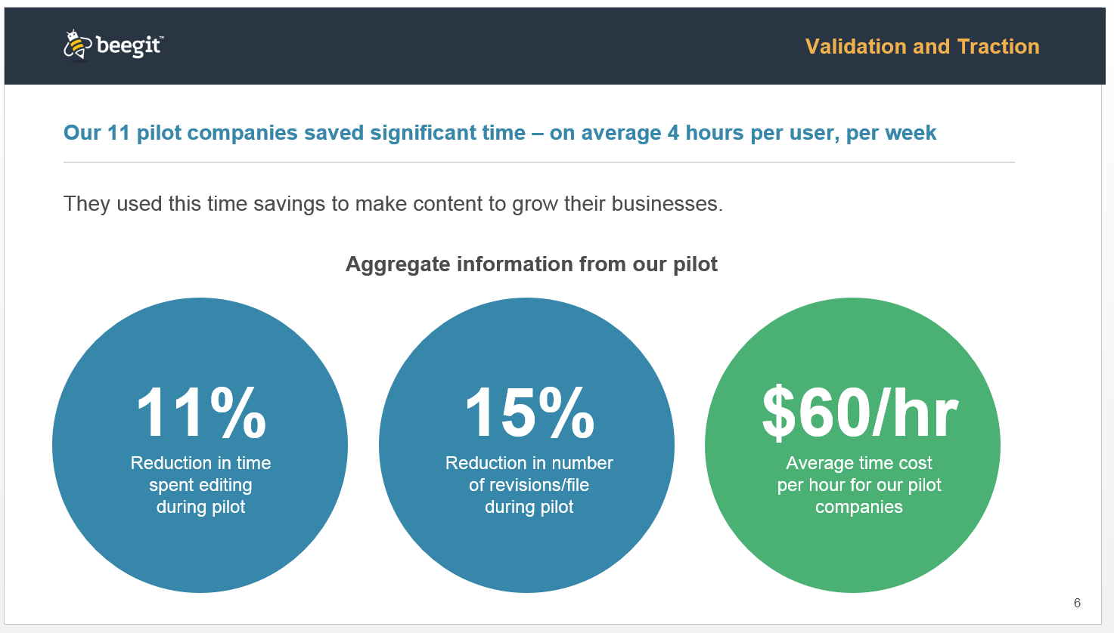

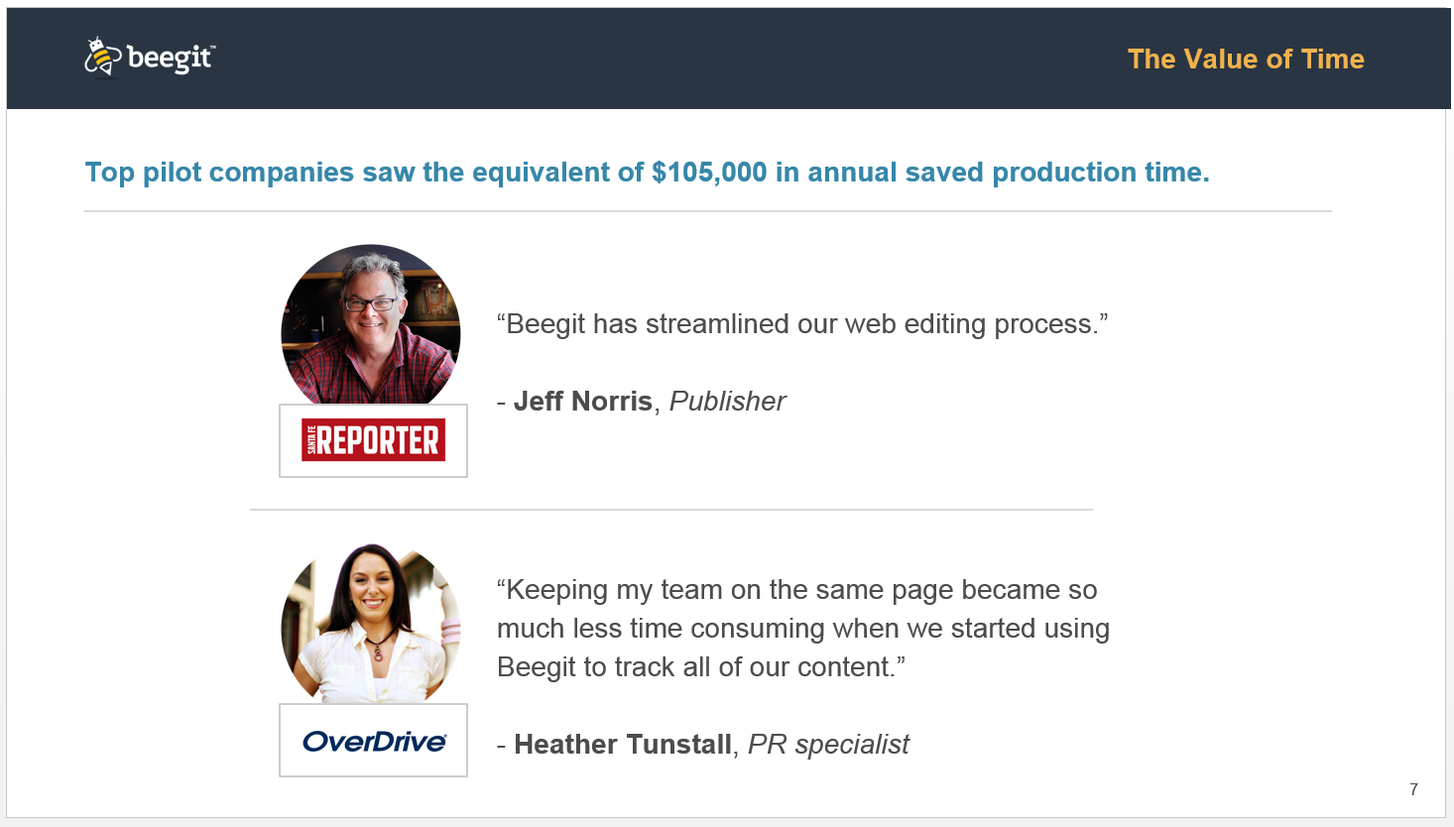

***What to Do:***

* Include customer stories or testimonials. Quotes will go a long way.
* Include accolades or press mentions that are relevant.
* Display LOIs (Letters of Intent). They demonstrate a more realistic version of potential traction.

***What Not to Do:***

* Do not over-dramatize your traction.
  + Examples from Coding VC:
    - "We recently launched and are on track for a million dollars in revenue this year."
      * The investor will assume you made $20k last week thanks to your pre-launch press push, then multiplied that number by 52 weeks.
    - "Our consumer app's user base has been doubling weekly for the last two months."
      * The investor will assume that in week 1, the only users were the founders. Now in week 8 you have 400 users.
* Investors see through these examples because they are commonly used.

## **Market Size/Opportunity**

* Identify your target market.
* Must show large and addressable market.
* [Click here for an example of a Market Size slide](http://pitchdeckcoach.com/pitch-deck#market-opportunity-slide) and [here for another example of a market size slide](http://imgur.com/MJRoFbR).

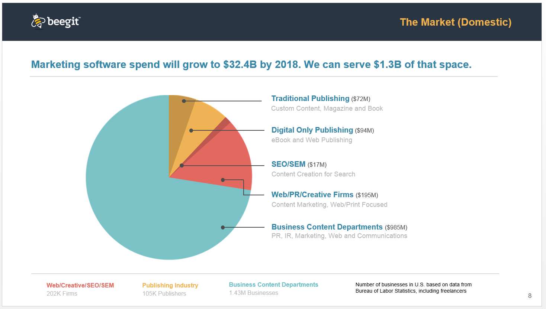

***What to Do:***

* Provide references for any data included.
* Should have third party validation of market size and growth.
* It’s helpful to distinguish between your Total Available Market, Total Serviceable Market, and your Initial Market.
  + [Here is a 4 min video that walks through an explanation of TAM, SAM, and Target Market (aka Initial Market)](https://www.youtube.com/watch?v=_-N5u7i_Vgk)
  + [Here is image that offers an explanation of TAM, SAM, and Initial Market.](http://image.slidesharecdn.com/marketsizing-20130129-130428104037-phpapp01/95/market-sizing-tam-sam-som-target-market-9-638.jpg?cb=1367146745)
  + [The first 15 minutes of this video includes professional guidance from a venture capitalist offering and explaining the methodology a company can use to determine the size of a market it can reasonably serve](https://www.youtube.com/watch?v=K_w9r88xUPk).
* Understand and be able to articulate what are the drivers of your market size.

***What Not to Do:***

* Do not claim your plan is to capture a percentage of the market without explaining the thought process and activities that can result in achieving this over X period of time. Try to give exact numbers (i.e. 100 hospitals, 1,000 accounting companies, 3.5 million users, etc).
* Avoid being unrealistic. That is the fastest way to lose credibility.

## 

## **Competition**

* List competitors and where you compare in the competitive landscape.
* Another popular way to display the competitive field other than the table Beegit used below is with a [2x2 competitor value matrix](http://image.slidesharecdn.com/gettingbehindtheperfectpitchv9photosandscript-forslideshare-120228232154-phpapp01/95/getting-behind-the-perfect-pitch-harvard-innovation-lab-workshop-34-728.jpg%3Fcb=1378971439). Here is an [example of a 2x2 using real brands](http://www.startupshk.com/wp-content/uploads/2013/07/ambi.jpg)
* [Click here for an article that gives a summary of 3 different ways to illustrate your market’s competitive landscape.](https://rivalfox.com/blog/how-to-sound-smart-and-raise-funds-crafting-a-competitive-analysis-for-your-startup/" \t "_blank)
* [The second 15 minutes of this video (about minutes 15-30) conveys how to analyze a competitive landscape from a professional investor’s perspective.](https://youtu.be/K_w9r88xUPk?t=16m11s)
* No matter how you illustrate this slide, always highlight your company’s unique competitive advantages in contrast to your competition.

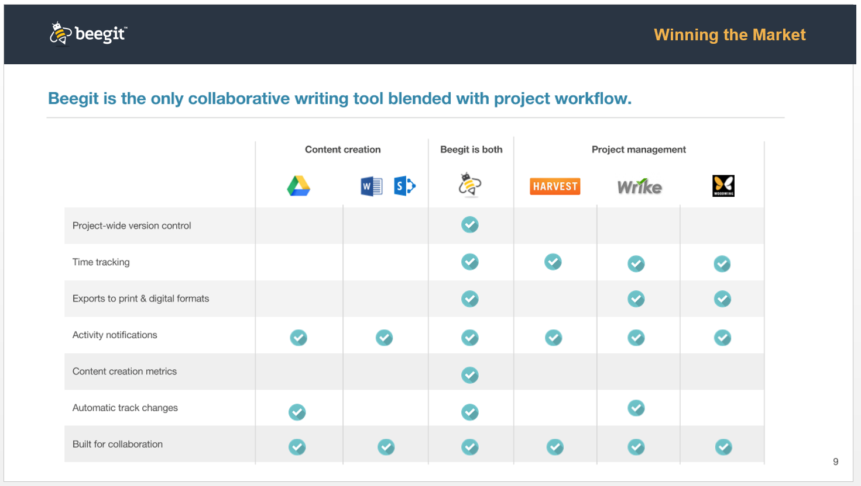

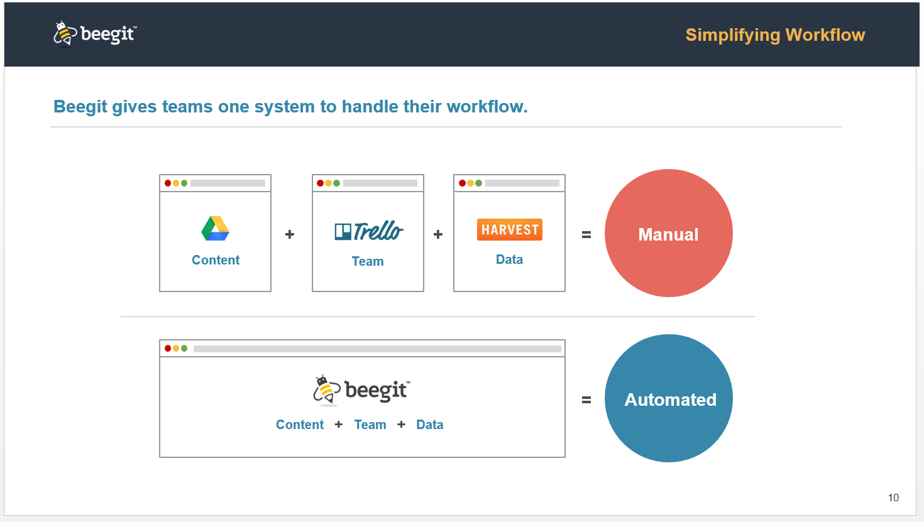

***What to Do:***

* Show all types of competition and explain your competitive advantage.
* Steer into risk factors, be honest and transparent.
* If required, use a secondary slide to show how you differ from the competition.
* If possible, use the [2x2 competitor value matrix](http://image.slidesharecdn.com/gettingbehindtheperfectpitchv9photosandscript-forslideshare-120228232154-phpapp01/95/getting-behind-the-perfect-pitch-harvard-innovation-lab-workshop-34-728.jpg%3Fcb=1378971439) or a check list table similar to the one used by Beegit above to convey any barriers to entry for your competition that you might be creating.
* Does your business model differentiate you from your competition? If so, you should clarify. [Here’s a Harvard Business School video highlighting how a business model can create competitive barriers.](https://www.youtube.com/watch?v=K0Eu6cL0BR8)

***What Not to Do:***

* Do not belittle your competition.
* Do not ever state there is no competition – status quo or lack thereof is often an ignored alternative to your solution/product. For instance, imagine you are selling a marketing tool to large companies. Even if no other competitors are offering the same tool, a large company only has X amount of dollars in its budget to spend. Therefore, you are competing with anything else a company might purchase with its marketing budget.

## **Go to Market Strategy**

If you were successful in convincing the investors that there is a big need that your product can solve, this section comes in as a close second in importance because this is where the rubber meets the road. This is where you will lay out a believable plan of how you will grow your business and how long it will take.

* [Here is a 2-part Harvard Business School workshop video covering Go To Market-Strategy](https://www.youtube.com/watch?v=AaoIuwepucM%20) and [Go To Market-Tactics](https://www.youtube.com/watch?v=sBNRg4ueVFE%20).
* How will you market to prospective customers? What methods and means will you use to reach your customers and why do you think they will work? Provide any proof you have that this can be achieved.
* How will you sell to your prospects? Will you use outbound and inbound sales reps? Will you use telesales? Will you use partners and how important are they? What else? Also provide any evidence that these are the best ways to proceed considering your market.
* How will these methods described here help you achieve your target growth rates?
* Revenue model—how will you make money?
  + How much are you going to charge?
  + What will be your conversion rates?
  + [Here’s a Harvard Business School video titled How Are You Going To Make Money?](https://www.youtube.com/watch?v=Gi8qSL6I9cE&index=3&list=WL" \t "_blank)
* Along with reviewing Beegit’s Go To Market slides below, also [see other examples of Go To Market slides here](http://imgur.com/VtV9gZa) and [here](http://imgur.com/6Bn8JOu).

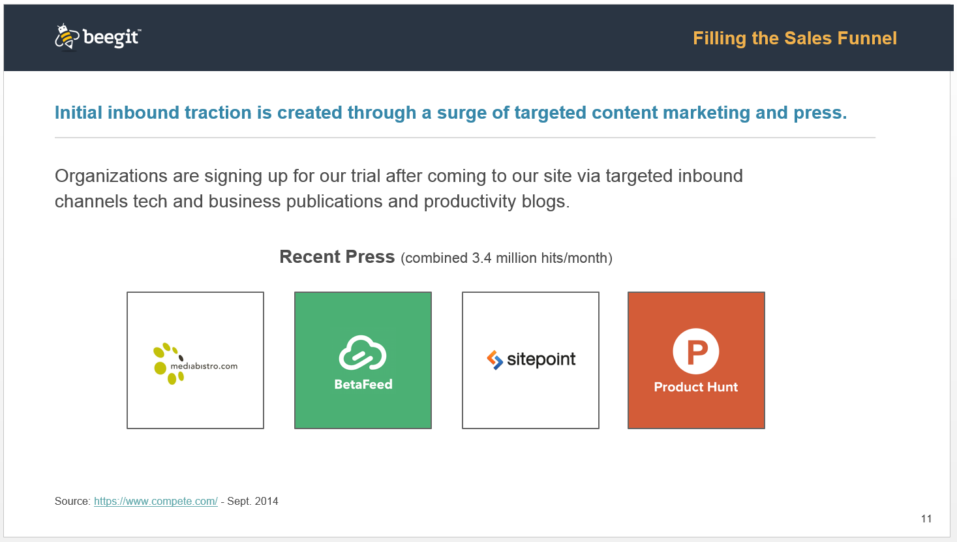

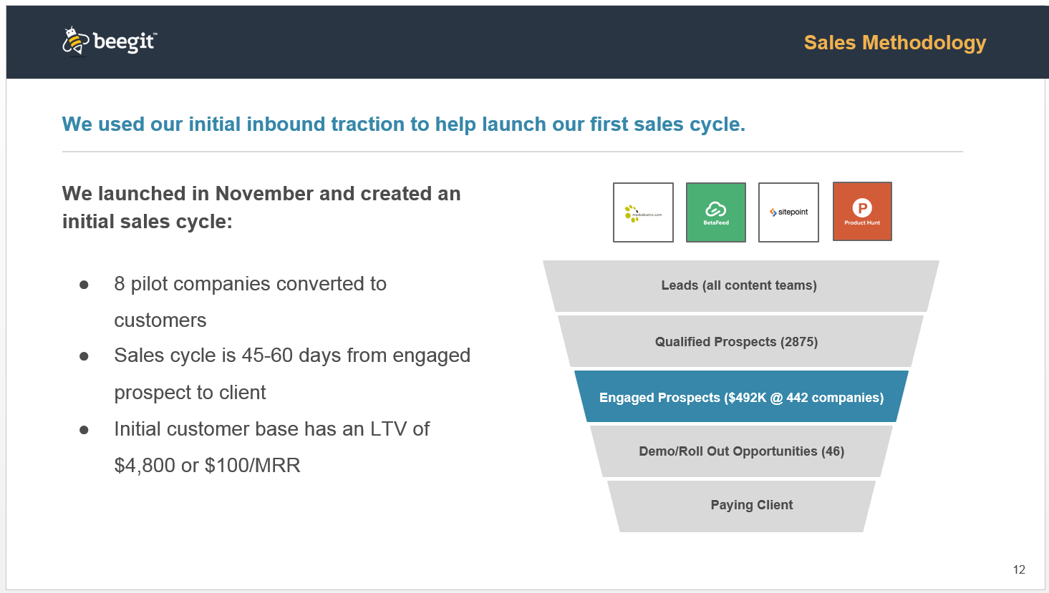

***What to Do:***

* You can show multiple growth options but don’t say you have five options, explain which route you plan to take, but that you have options and maneuverability.
* Explain “why” and “when” you are taking every option. You are not going to hit every market and channel at the same time. It’s not realistic nor believable.
* Illustrate your sales funnel if one has already been developed. It represents a thought out process of repeatable sales acquisition. For the sake of time and amount of slides, you may just want to mention that you have a sales funnel created and have it as an appendix slide that you can refer to in the Q&A.
* Be prepared to answer questions on strategies for each stage of the sales cycle. Expect questions about the relative length of time of the sale cycles and the cost-intensity of your different Go To Market strategies.
* Know the factors that could accelerate versus slow down your sales cycle
* Understand your Cost of Acquiring & Retaining Customers (CARC) and the Life Cycle Value (LCV) of your customers. Investors like to see LCV = 3x CARC. [Click here for an article that provides a further explanation of CARC and LCV.](http://www.forentrepreneurs.com/startup-killer/)
* Are you an early-stage company that only has a prototype/pilot…maybe just an idea? You may want to watch [Harvard Business School’s video covering Minimum Viable Products and faking it until you make it.](https://www.youtube.com/watch?v=M_tKYvPKN7U)
* If possible, provide insight into how you anticipate the market to evolve and how your company will fit in this changing environment. This is your opportunity to demonstrate that you understand market drivers and trends. Remember the quote by Wayne Gretzky, “You need to be skating to where the puck is going, not where it is…”
* Tie the numbers from your marketing and prospect acquisition strategy to your sales revenue (found in the next section, Financials). Even if you are pre-sales, investors want to see that your math for going from prospecting to acquisition adds up.

***What Not to Do:***

* Do not fail to include your distribution strategy.
* Avoid the “if we build it they will come” mentality.
  + [Here’s a Forbes article clarifying the pitfalls of the “if we built it, they will come” strategy.](http://www.forbes.com/sites/georgedeeb/2013/11/06/if-you-build-it-they-may-not-come-budget-ahead-for-startup-marketing/)

## **Financials**

* Three to five year forecast
  + [Here is an example of a financials slide with further explanation](http://pitchdeckcoach.com/pitch-deck#financials-slide)
* Key assumptions in your model of expenses, customer conversion, and market penetration rate.
  + Total Customers
  + Total Revenue
  + Total Expenses
* The ask/deal

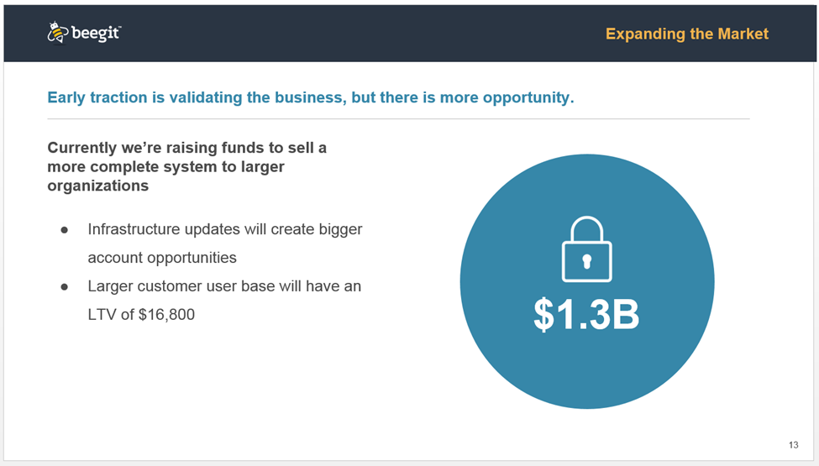

***What to Do:***

* The goal of your financials forecasts is not to make exact accurate projections, but rather be directionally correct and articulate the thought process behind conclusions.
  + Highlight your assumptions, milestones, and the metrics that generate your projection’s numbers.
  + Recognize important milestones/value creating drivers – key hires, product beta, market entry, first customers, channel partners, etc.
* Highlight what milestones need to be reached before your next round of funding.
* Make sure your projected revenue ties with your Go To Market strategy figures.
* [Here’s an example of an Ask Slide](http://image.slidesharecdn.com/pitchdeckcoachtemplate-150323101614-conversion-gate01/95/pitch-deck-template-16-638.jpg). Note how it’s a good idea to tie “the ask” back to the financial model on your financials slide. It’s also a good idea to highlight if you’ve received previous funding or have other investment committed (if applicable).
* Use a range in your valuation. Don’t give an exact value (ex: $760,000).
* The typical early stage technology company with no customers has a valuation of $500,000-$1 million.
* Leave room to negotiate.

***What Not to Do:***

* Don’t make your financial slide too wordy or number heavy.
* Investors do not like to fund debt repayment, back-pay, legal fees or R&D.
* Do not say that you will not need future funding. You will.

## **Team**

* Founders & Management
  + Highlight domain expertise and entrepreneurial successes
* Board of Directors/Board of Advisors

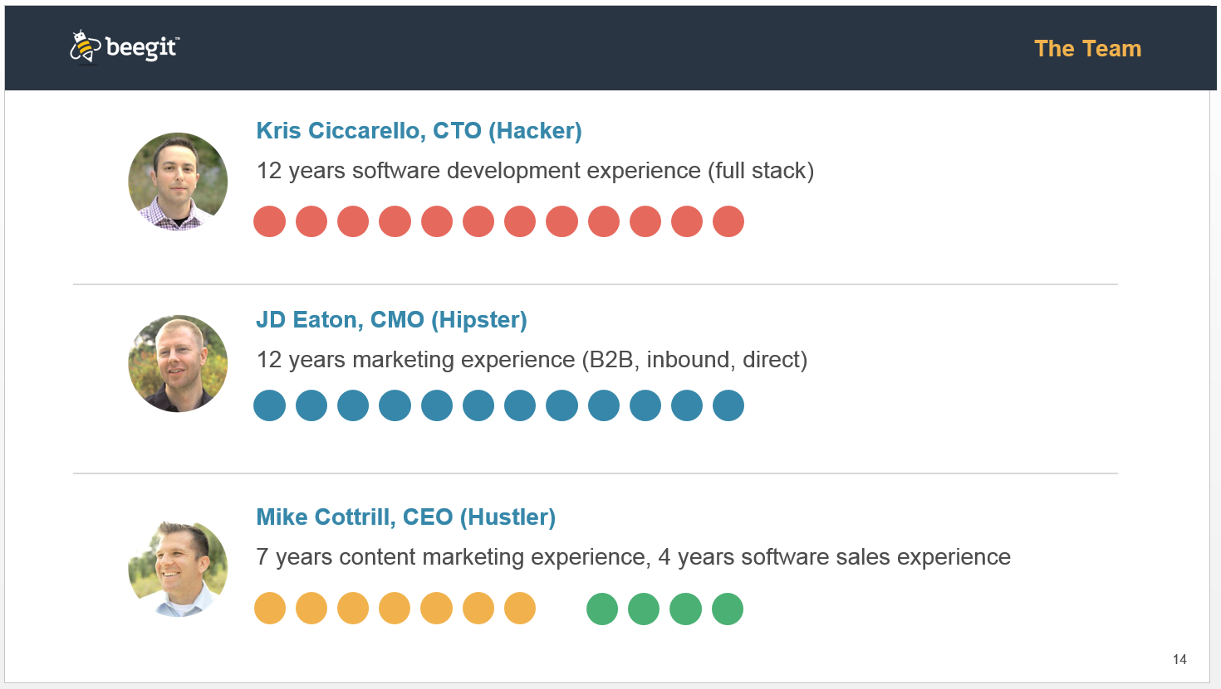

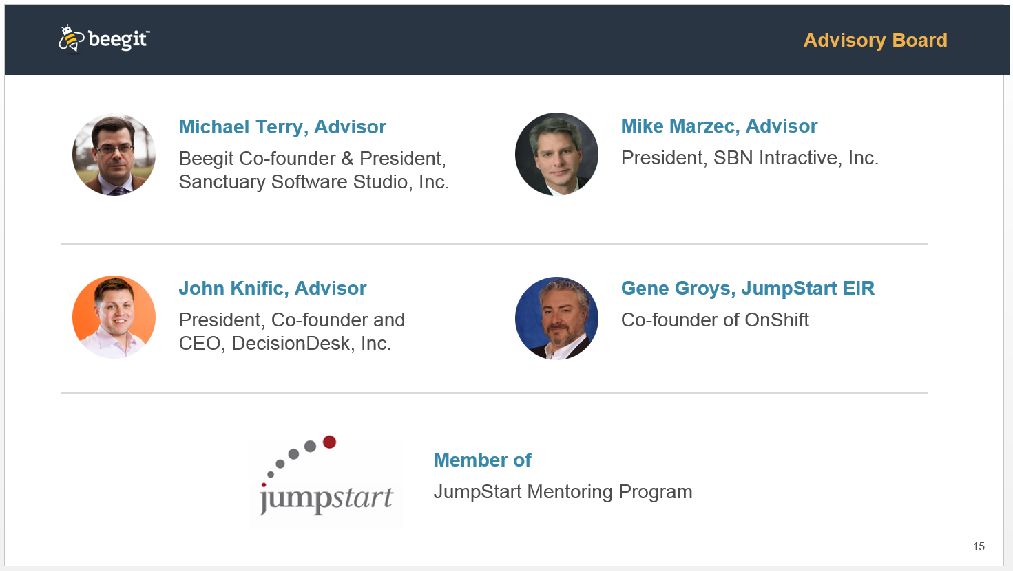

***What to Do:***

* It is understood that you will have holes that need to be filled. Investors want to see that you’ve considered your weaknesses/limitations and look to resolve them.
* CTOs should prove they have a strong technical background.
* Entrepreneurs should highlight the companies they’ve sold or success stories.
* Head of Sales/Marketing should prove they have helped a company become profitable or generated revenue.
* If you are the sole team member, make sure to list your advisors.

***What Not to Do:***

* Less text is more text.

## **Summary Slide**

* Many pitches start & end (or at least end) with a summary slide. Since you'll want to leave a slide up while you answer questions, it’s recommended that you have a summary slide on hand to end on a high note. Here’s an [example of a summary slide](http://pitchdeckcoach.com/pitch-deck#summary-slide).
* It’s also suggested that you once again provide your contact info on the summary slide so while you’re answering questions the audience can write down your contact info.

## **Appendix**



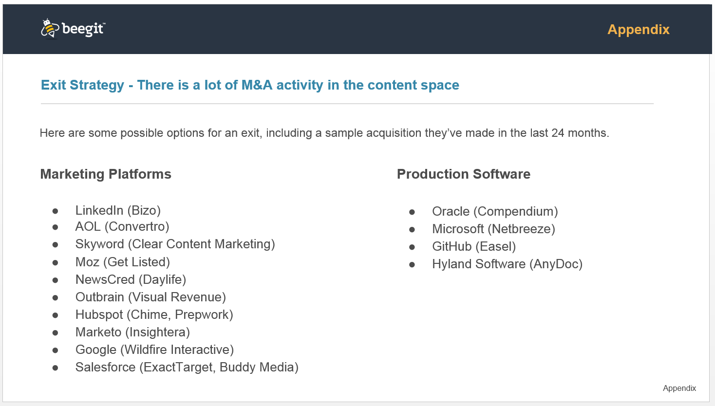

***What to Do:***

* Always have back-up slides.
* If applicable, many companies put an Exit Strategy slide, Ownership Structure slide, and a Sales Funnel slide in the appendix’s extra slides just in case these questions arise

***What Not to Do:***

* Avoid oversharing in the pitch so you have information to share during questions and answers